**How to Use LootParse**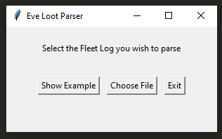

**Do not modify the Output Log in any way**

To the right is the interface on launch.

**To Show an Example**

Show Example will show an example of the program running without opening a file dialog

**To Exit**

Exit will close the sql file in use and exit the program

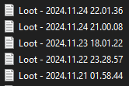

**To Parse a Log File**

Select ‘Choose File’ to open a file dialog where you can select the fleet log output

In the folder provided for grading, these files have been renamed to “LootParse Data #” for easier tracking.

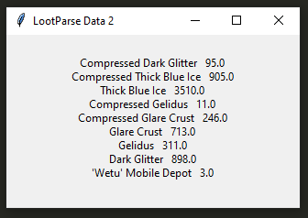

**That’s about it!**

There’s nothing more to it! Select the file you want to parse, and your output will open in a new window.